*DAINTY* OF THE ROYAL YACHT SQUADRON, 1923

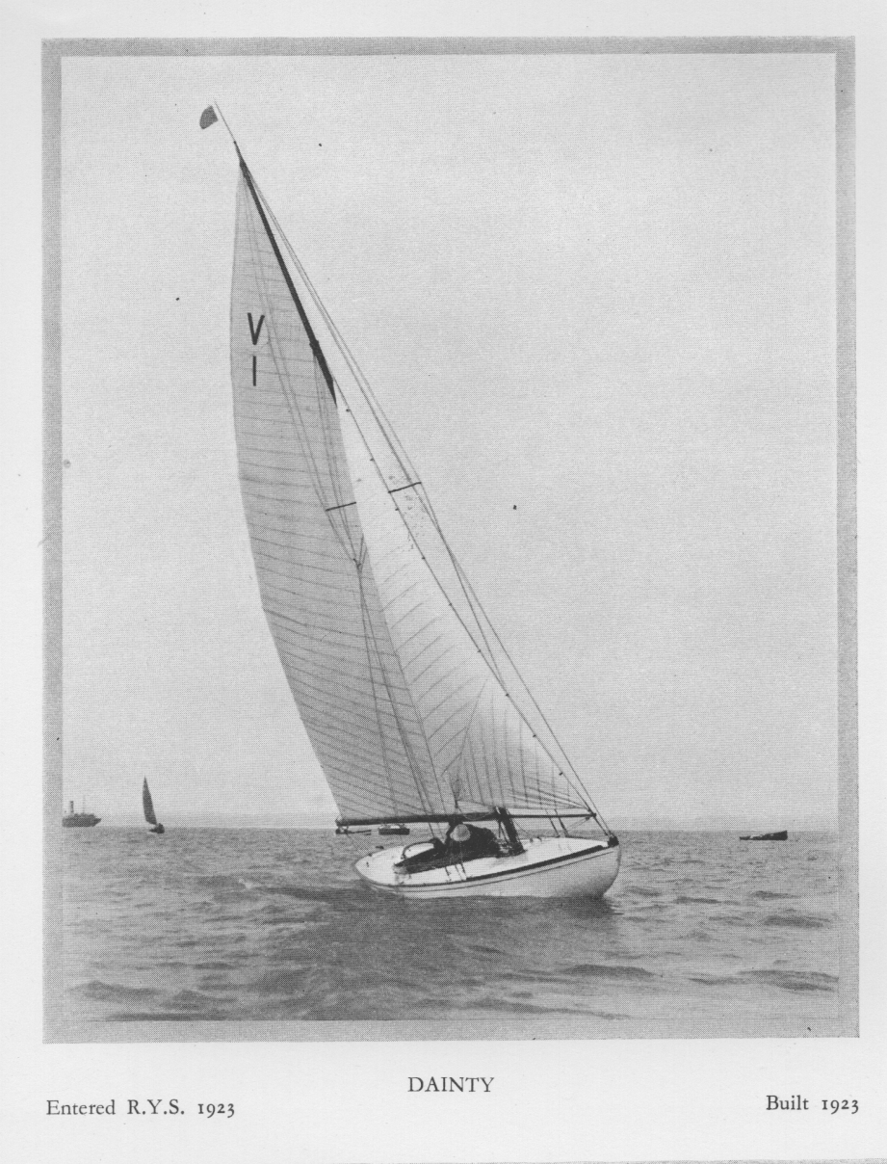

Illustration in *Yachts of the Royal Yacht Squadron* by Sir John Shelley-Rolls, published 1933

**HOW DAINTY JOINED THE ROYAL YACHT SQUADRON IN 1923**

1. Captain A. Basil Lubbock, MC, 1876-1944, the distinguished sailor and author was the brother of Lord Avebury and educated at Eton. But not for him the comfortable life on a family estate or on a City desk; in 1897, aged 21, he travelled to Canada and the Chilcoot Trail into Klondyke in the second year of that gold rush.
2. 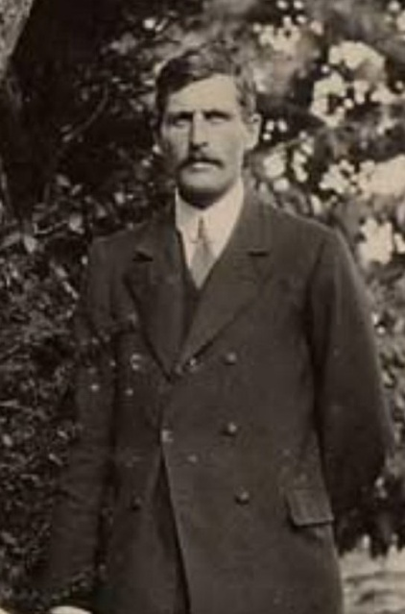On leaving Klondyke, presumably without a fortune in gold, he enlisted on a four-masted barque as an ordinary seaman and came home round the Horn. This was the start of his obsession with tall ships, about which he was to write 20 books, telling of the building, the rig and the voyages, of such as the Colonial Clippers, the Blackwall Frigates, the Cutty Sark, the Coolie Ships, the Opium Clippers, the Arctic Whalers and of his voyage Round the Horn before the Mast.   
   During the Boer War he held a commission in Menne’s Scouts, a South African corps. In the First World War he served in India and France and was awarded the Military Cross for saving life under fire.  
     
   Back home at Riverside Cottage, Hamble, his own sailing on much smaller vessels led him to become Commodore of the Hamble River Sailing Club, who asked him to find a new one design yacht.
3. Together with the eminent naval architect Alfred Westmacot he commissioned, had designed and built the Solent Sunbeam Class. The racing dayboat was one of the first classes with a Bermudan rig. Lubbock took ownership of V1, *Dainty.*
4. In 1923 Dainty won the Solent Sunbeam Class’s inaugural Cowes Week and Basil Lubbock with Dainty, were invited to join the Royal Yacht Squadron.
5. Dainty remained in the Squadron for 11 years, until Basil Lubbock sold her in 1934.
6. George Brooks, RYS 2007, had become an owner of Dainty in 1976.  
    Captain A. Basil Lubbock, MC

##### *DAINTY*, V1

A BRIEF HISTORY

Launched 1923 • Solent Fleet • Pale Yellow

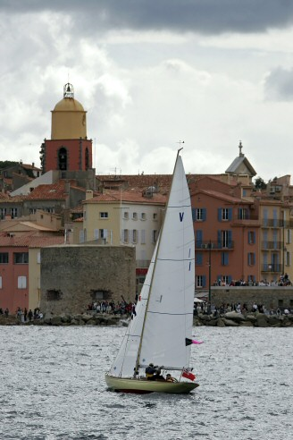Sail Number 1 drawn by lots at founding meeting of the class

for Captain Basil Lubbock who, as the Commodore of Hamble

River Sailing Club, had commissioned the design from Alfred

Westmacott and was elected the first Class Captain (1922-1930).

When the Sunbeams, seven of them, first raced in Cowes Week,

at the Royal Yacht Squadron’s regatta on Wednesday 8th August

1923, the programme included a race between Britannia, 221 tons,

Nyria, 169 tons and the relative minnows, Candida, 56 tons and

Dorivia, 50 tons. Also on the programme were the three 12

metres, Vanity, Morlen and Atalanta. The six metres were in their

heyday.

He raced her most keenly and successfully; in 1923: 46 starts

and 11 firsts, 1924: 46 starts and 10 firsts, 1925: 57 starts and 10

firsts, but did not race her when the fleet moved to Bembridge in 1930.   
His trophies include the 1923 Royal Yacht Squadron Regatta in Cowes Week, the Hamble River Points Series in 1924 and the Castle Yacht Club cup in 1924.

1934: F Ellam at Itchenor. 1936: A Rees-Reynolds, 1937: W C & W R Matthews.

1957 sold out of class to Eric Combes and laid up in Bosham until 1965 when, on the instigation of Henry Chisholm, Paul Brauner bought her, for £410 cash, and brought her into racing condition.   
1966: Paul invited his old friend Star Class world champion, ‘Bimi’ Fischer to helm and to win the Betty Moore cup for Cowes Week.

After partnerships with Jon Pither and George Brooks, run by Peter

Nicholson, who won McMeekin Trophy in 1977 and 1980 and the Betty Moore Cup 1976, 1978 and 1997 for Cowes Week, in which *Dainty* continues to compete every year.

Peter Nicholson was Solent Division captain 1979-1981.

1999: With David Giffard, sailed *Dainty* from Cowes to Falmouth, in three days, for the Falmouth Sunbeams 75th Anniversary Championships.  
 2001: Jubilee Round the Island, withV43 Honey.

2003: Boldly Go to Poole.   
2004: Falmouth Championships.

2005-15: annual trips overland to the Mediterranean in the Autumn for the Régates Royal Cannes and Voiles de Saint-Tropez.

Dr Michael Hollis joint owner.  
2008 Awarded Classic boat’s “Most Gentlemanly Yacht” prize at Cowes Classic Week, the Burnford Needle at Itchenor (For turning up so other yachts could win prizes?), Ist in Olympic Anniversary race off Bembridge. Twice winner of Panerai Classic Challenge Shield at Régates Royales, Cannes and, " la tape de bouche du Yacht Club de France",   
presented at Saint-Tropez by Patrice Brunet, Vice-President of Yacht Club  
 de France, for the Sunbeam's contribution to classic yacht racing in the Mediterranean.

*Dainty* before race in Voiles de Saint-Tropez

Further Information

The Solent Sunbeam web [www.solentsunbeam.co.uk](http://www.solentsunbeam.co.uk)

[The Brilliance of Sunbeams](http://www.solentsunbeam.co.uk/Brilliance%20of%20Sunbeams.html), published by the Sunbeam Class

©2015 Peter Nicholson. High specification photos and copyright [information available](mailto:peter@peternicholson.com)

